# Quick guide: colour polymorphism

Thomas E. White1, Darrell J. Kemp1

1Department of Biological Science, Macquarie University, Sydney, Australia 2109  
**Phone:** +61 2 9850 6279  
**E-mail:** thomas.white@mq.edu.au

**Keywords:** evolution, adaptation, variation, sensory ecology, communication

***What is colour polymorphism?***

Colour polymorphism is the presence of multiple discretely coloured variants within a single population, the rarest of which is too common to be due to recurrent mutation. A requirement that the variation be genetic is often adopted to distinguish polymorphism from polyphenism, which describes variation arising from interactions between a single genotype and varied environments. Sexual dimorphism, purely ontogenetic colour variation, and reversible colour change are also implicitly excluded. While polymorphism requires the coexistence of at least two morphs, the ultimate number of variants within a population can vary considerably. Dramatic examples include the 'exuberantly' polymorphic Hawaiian happy-face spider *Theridion grallator*, with over 12 morphs coexisting across four Hawaiian islands, and the poison strawberry frog *Oophaga pumilio*, with over 20 true-breeding morphs across their Central American distribution (Figure 1).

***How do they develop?***

Colour in nature is typically a combined product of pigments that absorb light, and physical structures that reflect it. Both are highly sensitive to changes in their chemical and/or physical structure, and so relatively subtle alterations of the underlying genes can give rise to dramatic shifts in final phenotypes. Unsurprisingly then, the genetic architecture and development of colour polymorphisms are highly variable. In simple cases, morphs may be determined by allelic variation at a single locus. The Midas cichlids *Amphilophus* sp., for example, exhibit a pigmentary dark-versus-gold polymorphism across both sexes that is controlled by a single dominant gene. In early life, both morphs are similarly dark thanks to broadly absorbent melanophores. In the ten percent of individuals that are homozygous for the recessive allele, however, these pigments degrade through ontogeny to expose the characteristic yellow-gold hue of underlying xanthopores.

Recent advances in sequencing have shown that polymorphism may be controlled by clusters of colour-coding and functionally unrelated loci that segregate as single supergenes. This physical linking of suites of genes allows for the maintenance of complex colour pattern variation within species while precluding less optimal intermediates, though much about how this is achieved remains unknown. Supergenes are particularly well documented among the strikingly ornamented *Heloconius* butterflies. In *H. numata*, each of seven morphs is determined by variation at a single locus. Unlike the Midas cichlids, though, this single locus is the switch for a supergene---constructed of numerous colour-coding loci---that controls chromosomal rearrangements corresponding to discrete wing colour patterns.

***Is it common?***

Colour polymorphisms are relatively rare, but are ecologically and taxonomically widespread. They occur in species that inhabit the majority of terrestrial and aquatic habitats, and are found in most major groups of animals (Figure 1), as well as among flowering plants. With respect to function, polymorphisms occur in all almost all contexts that involve colour. This includes sexual signalling, mimicry, aposematism, mutualism, crypsis, and prey luring.

***Why are colour polymorphisms puzzling?***

Colour is a conspicuous feature of the natural world. It is a valuable channel of information, and so is often under strong selection across functional contexts. Colour polymorphisms have long been of interest in evolutionary biology because theory predicts that purifying selection should erode such variation in favour a single optimum. The persistence of extreme variation therefore offers a simple visual tool with which to explore the processes that generate and maintain variation.

***So how is polymorphism maintained?***

Stable polymorphisms are thought to require some form of balancing selection to maintain equal fitness (on average) between morphs, lest a population be driven to monomorphism. There are several possible mechanisms, with varying degrees of empirical and theoretical support. Perhaps the best supported is negative frequency dependent selection, which occurs when rare morphs enjoy a selective advantage. This translates into greater relative fitness which, in turn, increases the rarer morphs' frequency until it becomes the more common variant. The process is particularly common in the contexts of crypsis, in which predators more readily learn the common morph, and in sexual systems, in which colour morphs often correlate with discrete mating strategies. The side-blotched lizard *Uta stansburiana* is a classic example. Males occur in three forms---blue, orange, and yellow throated---that map onto distinct strategies for territory defence. Importantly, each enjoys a rare-morph advantage over only one other morph. Blue males are susceptible to invasion from orange, who lose territory to yellow individuals, who, to complete the rock-paper-scissors dynamic, cede territory to blue males. The relative frequency of morphs predictably oscillates over short time scales, and the three-morph system appears to be evolutionarily stable.

Heterozygote advantage---where individuals that are heterozygotic at a given locus are fitter than their homozygous counterparts---is a well established driver of allelic variation. Although historically thought to play a role in the maintenance of colour polymorphisms specifically, the possibility has found little direct support to date. Geographic and temporal variation in selection is has also frequently been tied to colour polymorphisms, particularly in the context of visual signalling. Theory suggests that such variation may create distinct niches that favour polymorphic solutions. particularly in communication systems where viewing environments, and hence the appearance of colour signals, may change over small scales. Again it remains unclear whether this is sufficient unto itself to maintain stable polymorphisms, and recent theoretical work suggests that it may need to act in concert with other processes such as sexual selection.

Ultimately, extreme colour variation will often be subject to a suite of selective and neutral processes that will vary by species, and by population within species. Disruptive selection, secondary contact, hybridisation, gene flow, non-random mating, and genetic drift, as well as those processes mentioned above, have all be implicated in colour polymorphic systems. The full complement of processes maintaining polymorphism has been established for very few systems, however, and remains an ongoing challenge.

***What are the consequences of colour polymorphism?***

We discuss the ecological and evolutionary consequences of polymorphism, such as population structure and ranges, individual behaviour, and rates of speciation and extinction.

Genetic correlation (Mckinnon)

***Where can I find more?***

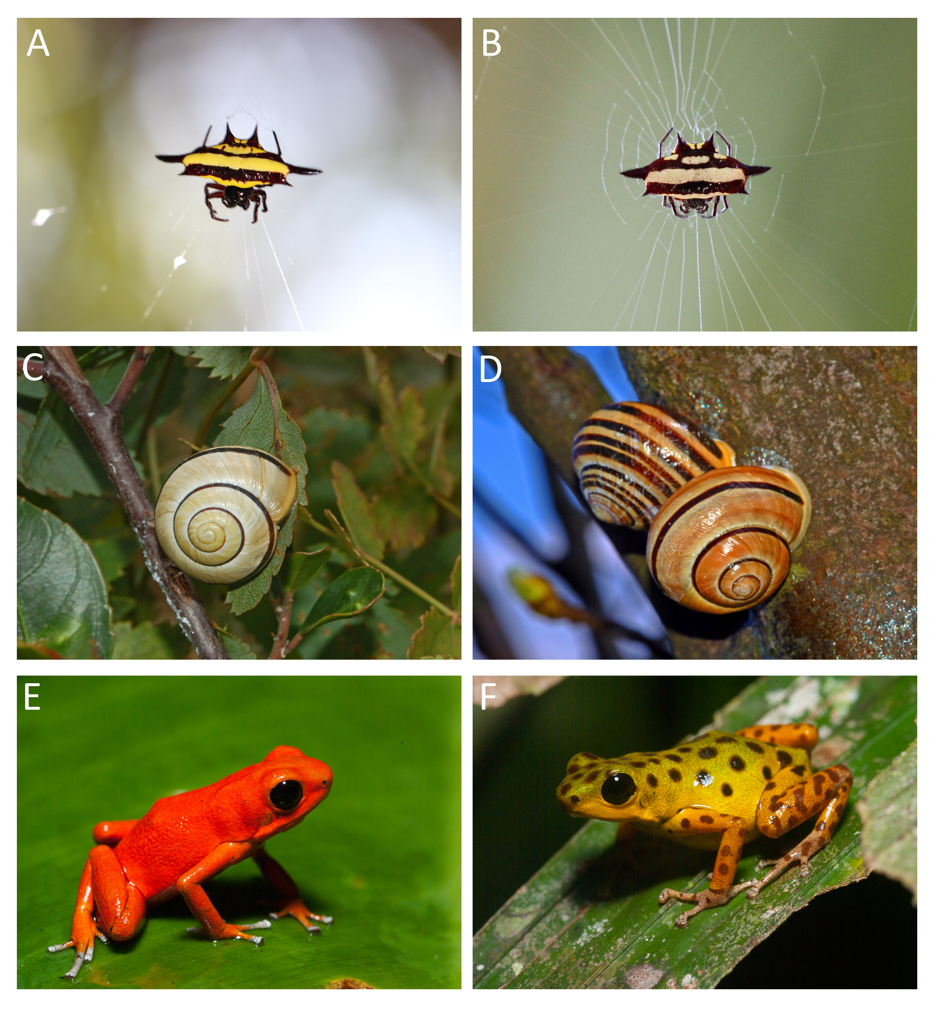

Colour polymorphisms in nature. (a, b) Both morphs of the spiny spider *Gasteracantha fornicata*, whose conspicuous colour patterns visually lure prey (Photos: Thomas White). (c, d) Colour and pattern variation in the highly polymorphic land snail *Cepaea nemoralis* (Photos: Ettore Balocchi). (e, f) Two of 15 morphs of the aposematic poison frog *Dendrobates pumilio* (photos: Justin Lawrence).

# References

1 Bond, A.B. (2007) The evolution of color polymorphism: Crypticity, searching images, and apostatic selection. *Annual Review of Ecology, Evolution, and Systematics* 38, 489–514

2 Gray, S.M. and McKinnon, J.S. (2007) Linking color polymorphism maintenance and speciation. *Trends in Ecology & Evolution* 22, 71–79

3 Wellenreuther, M. *et al.* (2014) Sexual selection and genetic colour polymorphisms in animals. *Molecular Ecology* DOI: <http://doi.org/10.1111/mec.12935>

4 McLean, C.A. and Stuart‐Fox, D. (2014) Geographic variation in animal colour polymorphisms and its role in speciation. *Biological Reviews*

5 Roulin, A. (2004) The evolution, maintenance and adaptive function of genetic colour polymorphism in birds. *Biological Reviews* 79, 815–848

6 Ford, E.B. (1945) Polymorphism. *Biological Reviews* 20, 73–88

7 Joron, M. *et al.* (2011) Chromosomal rearrangements maintain a polymorphic supergene controlling butterfly mimicry. *Nature* 477, 203–206